**TRIBHUVAN UNIVERSITY**

**INSTITUTE OF ENGINEERING**

**Lab Sheet #3**

**PURWANCHAL CAMPUS**

DHARAN-8

**Submitted by:** **Submitted to:**

Name: **Arbind Kumar Mehta** Department of

Roll No: **PUR075BCT017** Electronics & Computer

Faculty: BCT Engineering

Group: I/I ‘A’

Date: ….......................... Checked by: ……………………….

**Title:**

Get input of two float numbers in to variables x & y. receive the mathematical operator (+, -, *, /) using unformatted I/O into the variable Ch1 and perform operations on x & y and display the result.

**Objective:**

* To be familiar with different data types, operation, expression and unformatted I/O in C

**Problem Analysis:**

Based on problem, it is required to get the input of two float variables x and y. Different mathamatical operation should be performed by using unformatted I/O.

|  |  |  |  |
| --- | --- | --- | --- |
| **Input variables** | **Processing variables/calculations** | **Output variables** | **Necessary header files/functions/macros** |
| x, y (float type) | ch1 (char type) | ans(float type) | stdio.h  coino.h  scanf()  printf()  switch()  getch() |

**Algorithm:**

1. Start
2. Define variables: x,y,ans,ch1
3. Take input from keyboard for all the input variables
4. Use switch statement to get ans
5. Display the ans
6. Stop

**Flowchart:**

Start

Define variable: x,y,ans,ch1

Read x,y,ch1

switch(ch1)

case ‘+’

True True

Print “Result=x+y”

False

case ‘-’

True

Print “Result=x-y”

False

Print “Result=x/y”

Print “Result=x*y”

case ‘/’

case ‘*’

True

False

True

False

Print “Invalid choice!!!”

Stop

**Code:**

#include <stdio.h>

#include<conio.h>

int main()

{

float x,y,ans;

char ch1;

printf("Enter two numbers:\n");

scanf("%f%f",&x,&y);

printf("Press '+' to add,'-' to subtract, '*' to multiply and '/' to divide:\n");

ch1=getch();

switch(ch1)

{

case '+':

ans=x+y;

break;

case '-':

ans=x-y;

break;

case '*':

ans=x*y;

break;

case '/':

ans=x/y;

break;

default:

printf("Invalid choice!!!");

}

printf("The result is:%f",ans);

getch();

return 0;

}

**Output (Compilation, Debugging and Testing):**

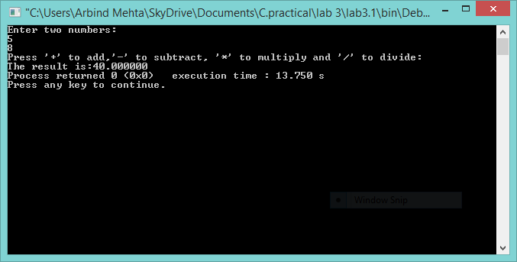

**Discussion & Conclusion:**

In this lab of C programming, based on the focused objective(s) to understand about C data types with unformatted input/output functions.